How to prepare the abstract for 17th International Conference on Liquid Crystals

A. Firstauthor^{1*}, B. Secondauthor², Z. X. Coauthor³
¹ Affiliation of presenting author, address, ² Affiliation of the second author, address; ³ Affiliation of the next author/s, address
* The corresponding author e-mail: user@domain.xy

The abstract must be prepared as one A4 page (297 mm x 210 mm) with all margins equal to 25 mm. The single-spaced text should be typed in Times New Roman font with use of the Microsoft Word editor (any version).
The abstract text starts at the top of the page with a title of your contribution (font size 14 pt., bold, centered). Skip one line below the title and type the authors’ name(s) in the following order: initial(s), surname (font size 12 pt., centered). Underline the name of the presenting author. On the next line, enter the affiliation of each author with full postal address; e-mail connection for the corresponding author is required (both 12 pt., italics, centered).
Skip one line and begin your abstract text (Times New Roman, 12 pt., justified). The abstract length is one A4 page only. You can place the text, equations, figures, references, etc. within the area available. For scientific equations, use only standard characters, Microsoft Equations Objects. The text may contain tables, chemical structures and figures. To avoid technical problems, we strongly suggest using PNG or JPG files for the inserted figures. Figure captions (12 pt., centered aligned) should not be part of the figures.
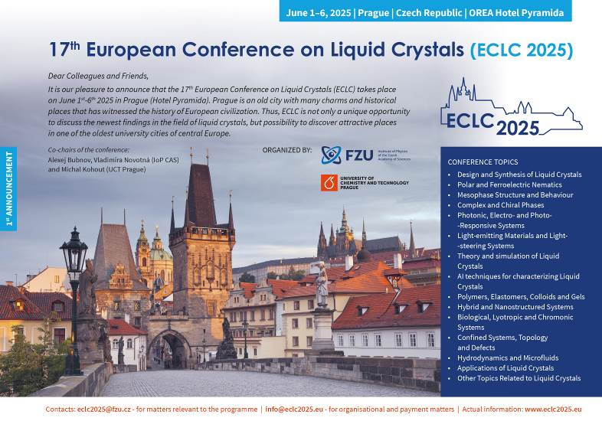
Fig. 1: The advertisement of ECLC2025 conference.

The recommended mode of submission is direct uploading at www.eclc2025.eu using your personal user page (log-in with your personal password) under “New abstract submission”. In case you need to modify the abstract, please resubmit your modified abstract via your personal user page under “Review of submitted abstracts”. Resubmission will automatically notify the administrator of database about the changes. Please do not submit the upgraded abstract as a new one. Please note, that it is not possible to change the title of the presentation; if you need to change it, please contact the organizers by e-mail: info@eclc2025.eu. Thank you for respecting the above instructions.

References
[1] K. Lastname, J. Lastname, B. Lastname, Journal name, 123, 456-478 (2009)
[2] M. Lastname, N. Lastname, A. Lastname, Journal name, 321, 456-478 (2014)

Acknowledgments
This work was supported by the Grant Agency (project No. XXXX).

